1.. input the points array int point[][] = {{50,100},{75,150},{100,200}} Use loop to traverse and draw the line Hint glVertex2iv(points[i]);

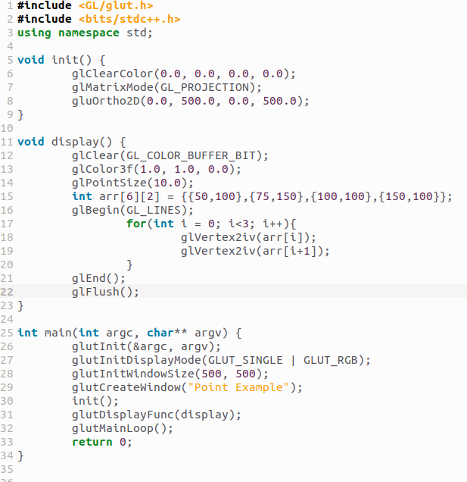

2. Define an array of points and connect them in sequence using lines. Ensure that the last point connects back to the first point to form a closed loop.

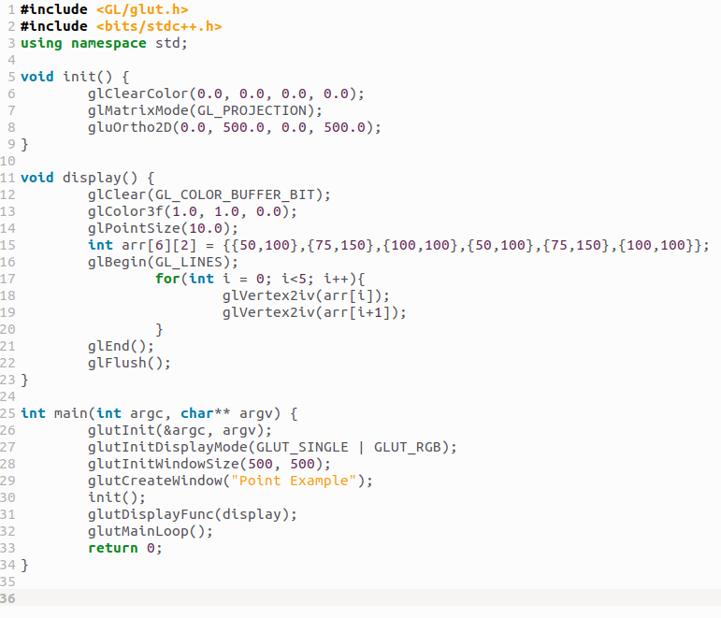


3. use a loop to draw a zigzag pattern using lines. Alternate the endpoints of the lines between two
horizontal levels.

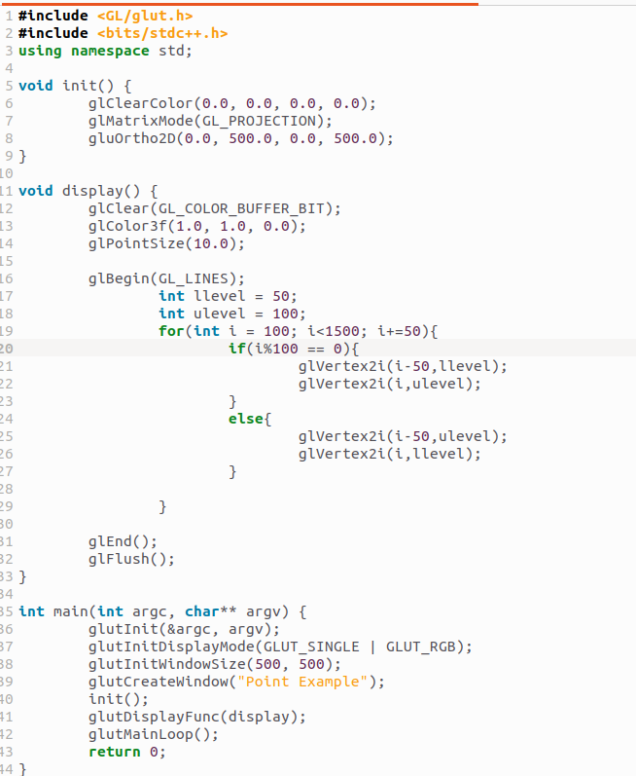
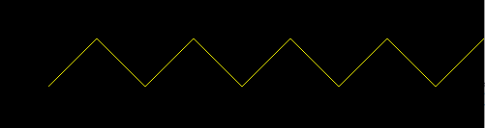

4. Draw a start shape by connecteing specific points using lines. Define the points of the star in an array and use glVertex2iv to render them.


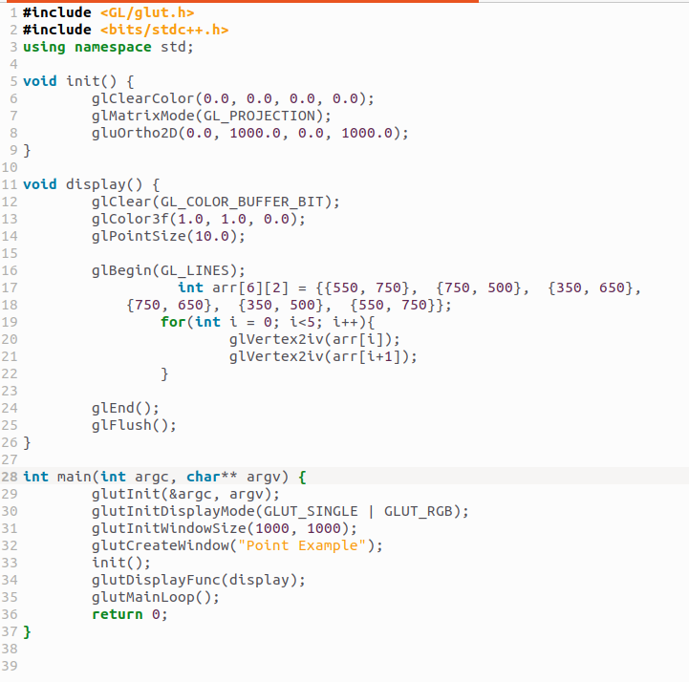

5. Implement a program to draw a line strip by connecting multiple points in sequence. Use an array to store the points and loop through them to render the strip

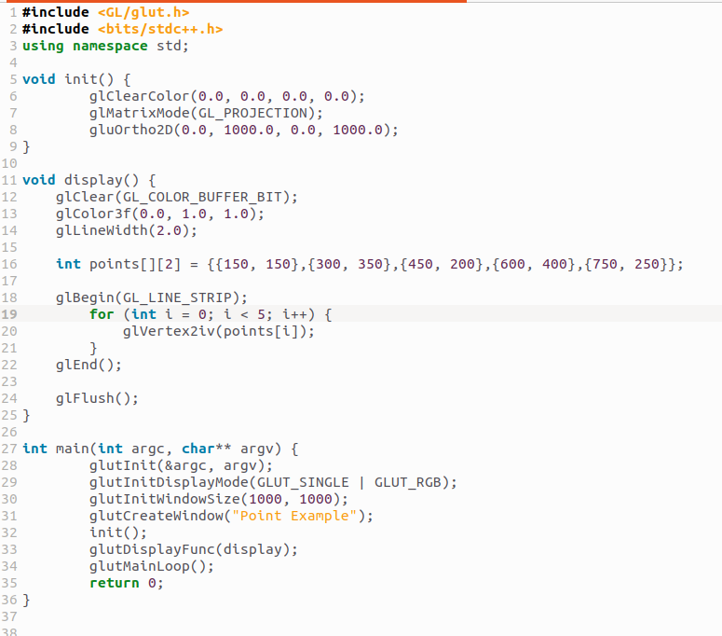


6. Allow the user to click on the window to place points dynamically. Use glutMouseFunc() to handle mouse input and plot the points in the clicked locations.
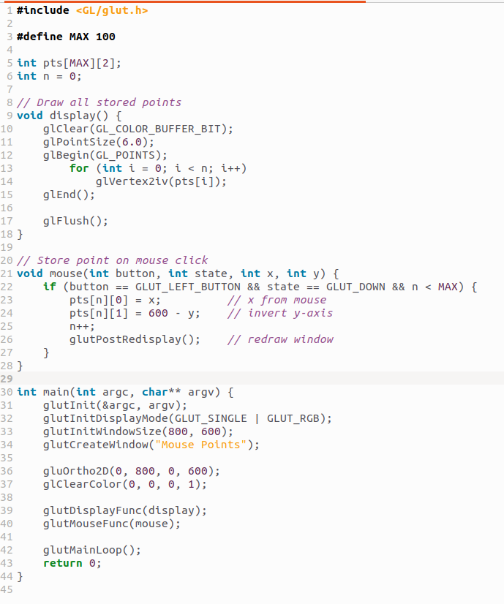


7. Write a program to draw a regular polygon (eg, triangle, pentagon) using loops. Allow the user to specify the number of sides. Use trigonometry to calculate the vertices of the polygon.

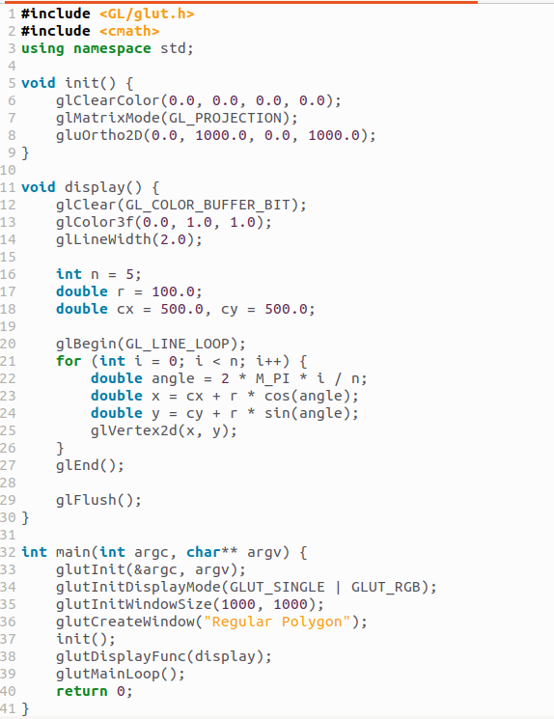


8.Combine multiple primitives to create a simple scene, such as a house with a roof, door, windows, using points and lines.

